|  |  |  |  |  |
| --- | --- | --- | --- | --- |
|  | | | | |
| AIUB | **American International University- Bangladesh (AIUB)**  **Faculty of Engineering** | | | |
| **Course Name:** | Microprocessor and Embedded Systems | **Course Code:** | EEE 4103 | |
| **Semester:**  **Spring 23,24** |  | **Term:** | Mid | |
| **Total Marks:** | 20 | **Submission Date:** | Exam Day | |
| **Instructor Name:** | Md Sajid Hossain | **Assignment:** | | 02 |

Course Outcome Mapping with Questions

|  |  |  |  |  |  |  |  |
| --- | --- | --- | --- | --- | --- | --- | --- |
| **Item** | **COs** | **POIs** | **K** | **P** | **A** | **Marks** | **Obtained Marks** |
| **Q1** | **CO1** | **P.a.4.C3** | **K4** | **P1, P3, P7** |  | **5** |  |
| **Q2** | **CO1** | **P.a.4.C3** | **K4** | **P1, P3, P7** |  | **5** |  |
| **Q3** | **CO1** | **P.a.4.C3** | **K4** | **P1, P3, P7** |  | **5** |  |
| **Q3** | **CO1** | **P.a.4.C3** | **K4** | **P1, P3, P7** |  | **5** |  |
| **Total:** | | | | | | **20** |  |

**Student Information:**

|  |  |  |  |
| --- | --- | --- | --- |
| **Student Name:** | **TRIDIB SARKAR** | **Student ID:22-46444-1** |  |
| **Section: F** |  | **Department: CSE** |  |

|  |  |  |  |
| --- | --- | --- | --- |
| **Submission link is in the notice section of the portal.** | | | |
| **Submission Date:** | **06 March, 2024** | **Due Date:** | **Exam Day** |

**Marking Rubrics (to be filled by Faculty):**

|  |  |  |  |  |  |  |  |
| --- | --- | --- | --- | --- | --- | --- | --- |
| **Problem #** | **Excellent**  **[5]** | **Proficient**  **[4]** | **Good**  **[3]** | **Acceptable**  **[2]** | **Unacceptable**  **[1]** | **No Response**  **[0]** | **Secured Marks** |
| Detailed unique response explaining the concept properly and answer is correct with all works clearly shown. | Response with no apparent errors and the answer is correct, but explanation is not adequate/unique. | Response shows understanding of the problem, but the final answer may not be correct | Partial problem is solved; response indicates part of the problem was not understood clearly. | Unable to clarify the understanding of the problem and method of the problem solving was not correct | No Response/(Copied/identical submissions will be graded as 0 for all parties concerned) |
| **1** |  |  |  |  |  |  |  |
| **2** |  |  |  |  |  |  |  |
| **3** |  |  |  |  |  |  |  |
| **4** |  |  |  |  |  |  |  |
| **Comments** |  | | | | | Total marks (20) |  |

1. In an alternate universe, where live forms with supernatural abilities are common, a top secret research lab is trying to implement a very robust security system against both physical and cyber threats. They have decided to build their physical defenses with an **ATMega328P MCU** at the center. As part of the security measures, the MCU is supposed to generate **two pulses of 80µs and 2s**. The team of engineers cleverly realized, they can easily generate these pulses by configuring the timer modules on the MCU. The MCU is running at 16 MHz and there are 3 timer modules (Timer0, Timer1 and Timer2) available of which Timer0 and Timer2 are 8-bit timers and Timer1 is a 16-bit timer. **The available prescalers are 8, 64, 256 and 1024**. It is apparent that 2 different timers need to be used for this purpose. **Select** 2 from the 3 available timers to be used for this system. Then **compute** the necessary timer counts to generate the stated pulse signals using the selected timers. To leave room for future changes, also **compute** the maximum pulses which can be generated using the selected timers if the MCU clock frequency remains unchanged at 16 MHz. [5]
2. To meet the conditions specified in Q1, at least 1 of the 8-bit timers needs to be used. **Prepare** the necessary registers associated with an 8-bit timer to achieve the time count computed in Q1. Consider the timer to be running in normal mode. [5]

[**Hint:** TCCRxA and TCCRxB have to be initialized. The useful bits of TCCRxA are bit 0 and bit 1 which represent WGMx0 and WGMx1 respectively. Bits 0 to 3 are the useful bits from TCCRxB. Bits 3 represent WGMx2. Bits 0 to 2 represent the clock select functions CSx0, CSx1, CSx2 respectively. Consider WGM = 0 for normal mode of operation. The bits not mentioned here can be ignored/considered as 0]

|  |  |  |  |
| --- | --- | --- | --- |
| **CS****x2** | **CSx1** | **CSx0** | **Prescaler** |
| 0 | 1 | 0 | 8 |
| 0 | 1 | 1 | 64 |
| 1 | 0 | 0 | 256 |
| 1 | 1 | 1 | 1024 |

**3.** A vending machine at a university campus will offer three different options for cold drinks. This machine will be able to dispense a maximum of 3 drinks at once. The machine will have a total of three buttons (button 1 for 1 drink, button 2 for 2 drinks, and button 3 for 3 drinks) to select the number of drinks to be dispensed. After this initial selection, the vending machine will wait for 3s and then display the options for available drinks. The consumer can use the 3 buttons (button 1 for A drink, button 2 for B drink, and button 3 for C drink) to select their desired drink(s). If only 1 drink is to be dispensed, the consumer will press the relevant button and the vending machine will dispense the chosen drink after a 3 s wait. If more than 1 drink is to be dispensed, the relevant buttons need to be pressed one after another and the machine will dispense the drinks one at a time with a 3 s gap between the consecutive drinks. This vending machine is to be built around an Arduino Uno platform. Now, **prepare** a program to execute the mentioned tasks if the Arduino Uno system is operating at 16 MHz. [For this program, digital I/O pins D0 to D9 can be used whose pin numbers are 0 to 9 correspondingly.] [5]

**4.** **Prepare** a flowchart for the program in Q3 to show the flow of logic. [5]

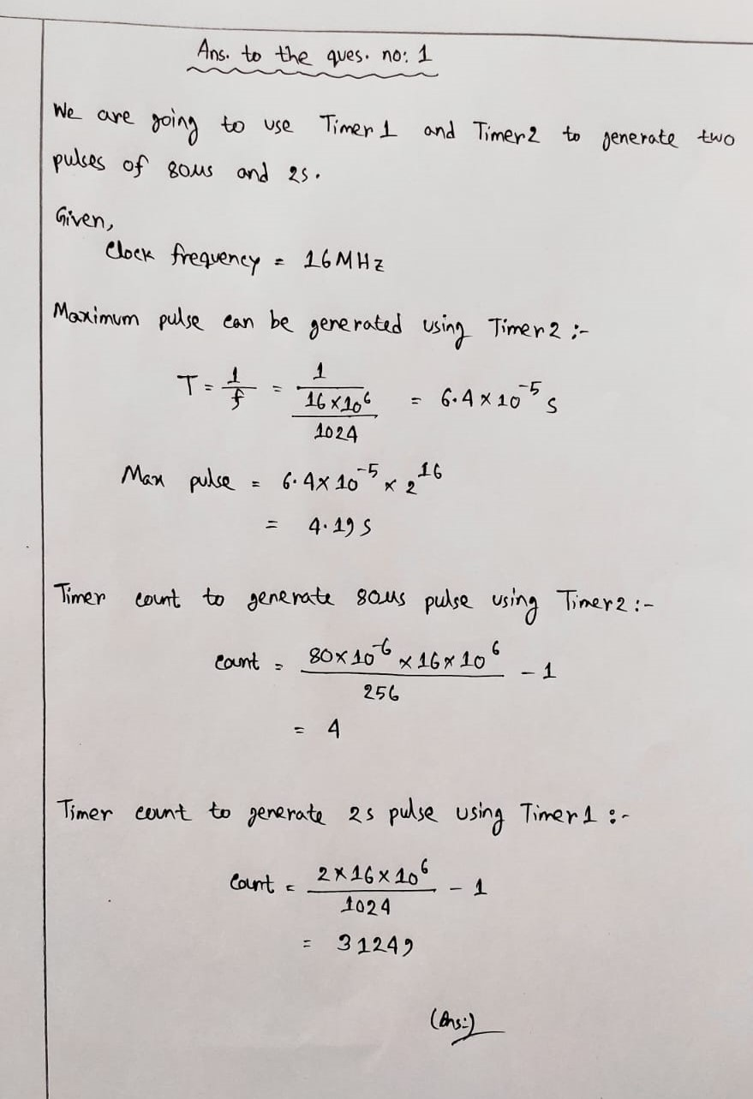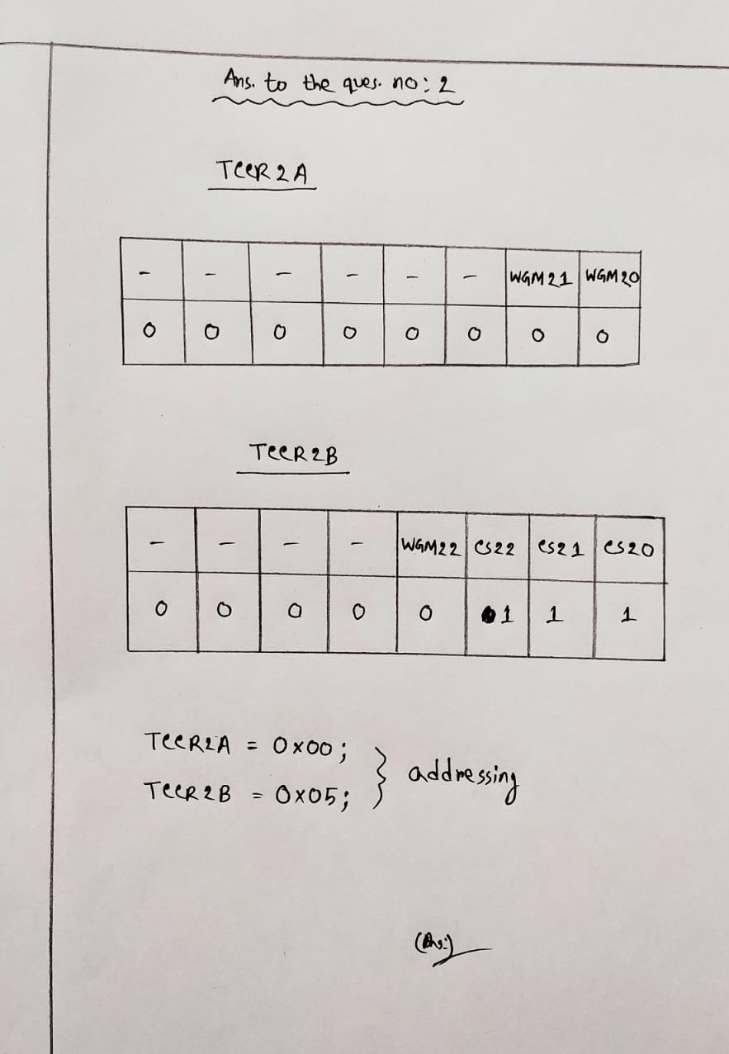

**Answer to the question no: 3**

